Spring 2025
Cse-5392 wireless Communications
the university of texas at arlington


lab 4 report
Submitted toward the partial completion of the requirements for CSE 5392
Under the guidance of
Prof. Jason Losh
By:
Dario Ugalde, 1001268068

Introduction
This lab focused on the construction and function of a simple antenna. This required the construction of an antenna and the process of wiring it up to connect it to the signal generator to provide a transmission source. A receive antenna was provided in lab to connect to the spectrum analyzer to verify the transmission source’s function. Successful completion of the lab provides knowledge on how antennas are made and how the transmission field of the selected antenna type can vary depending on the positioning of the receiver and the direction the transmission source is facing.

Steps 1 – 4: Frequency Selection and Antenna Construction
To begin the lab, a carrier frequency is selected. This choice will influence the construction of the antenna as the size of wavelength dictates the parameters of the shape of the antenna. For our team, we selected a carrier frequency of 725MHz. Once we determined the frequency, we also made the decision to use a folded dipole. This antenna type looks like a rubber band stretched from two points. In order to construct our antenna as close as possible to the optimal shape, we used an online folded dipole calculator to determine the shape. After molding the antenna from the copper wire, a coaxial cable was connected on each end of the antenna. The antenna was mounted on a wooden pole. This completed the construction of our folded dipole antenna. Figure 1 below provides a capture of the lab setup.

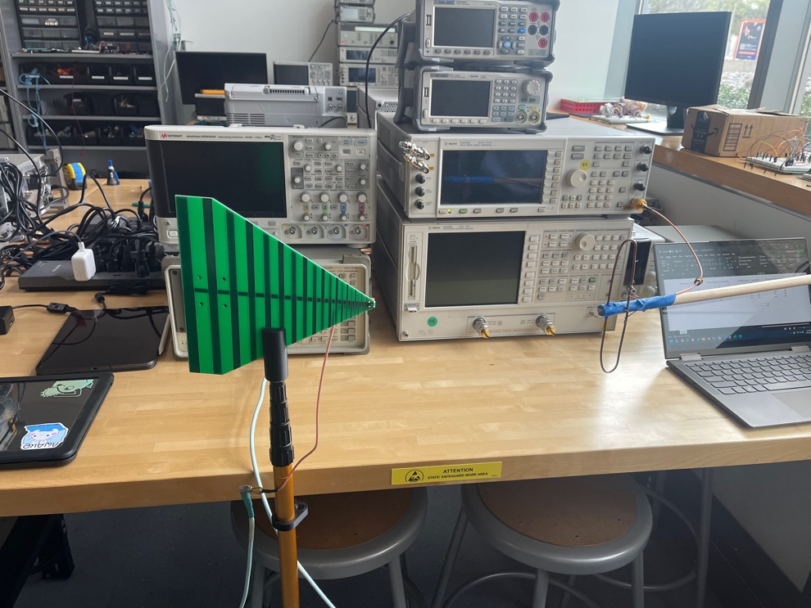
Figure 1. Lab 4 setup configured for our folded dipole

Steps 5 – 10: Antenna Testing
Once everything was wired up, we performed the required calculations to ensure our transmission was with the legal regulations. Using the provided calculator spreadsheet, we looked up the electric field transmission limits for our carrier frequency and found that it was 5,000μV/m. The gain of our antenna was determined to be 2.1dBi. After double-checking our measurements with the TA, we powered up the hardware and began transmitting with our antenna. Figure 2 below shows the spectrum analyzer capture for our chosen frequency and the power of field.

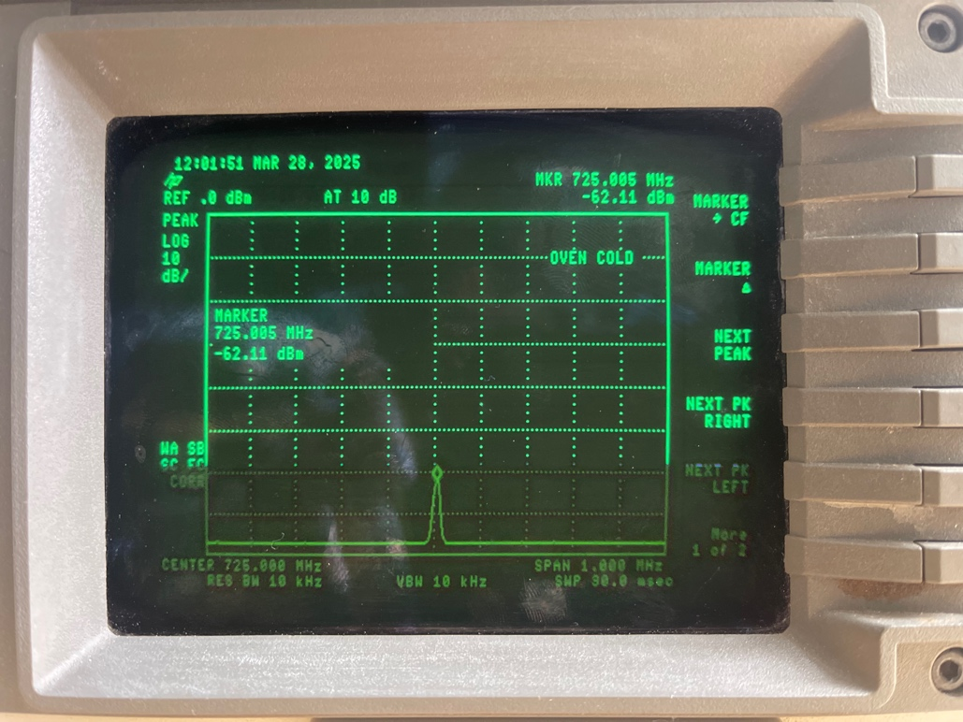
Figure 2. 725MHz carrier frequency captured on the spectrum analyzer from the PCB
Once the transmission capability was verified, we tested the transmission strength by getting dBm measurements at various distances that were multiples of the wavelength. For our 72MHz, the wavelength was calculated to be 0.413507m. Figure 3 below shows the measurements and was approximated at half a meter per step.

Distance(m) | Power(dBm)
3 | -61
2.5 | -57
2 | -55
1.5 | -54
1 | -53
0.5 | -51
Figure 3.Measurements of Power over varying distances
Figure 3 demonstrates how power decreases as distance increases. This property applies to all transmission sources. In class, we discussed how space satellites experience tremendous amounts of loss by the time the signal is received back on earth.

Step 11: Angle and Frequency Variations
Once the transmission capability was verified. We moved on to measure how rotating the receive antenna affected the power received by it. Figure 4 below demonstrates the effects of varying the angles of the previously mentioned antenna.
Rotation(Degree) | Power(dBm)
0 | -62
15 | -60
30 | -62
45 | -62
60 | -65
75 | -62
90 | -67
Figure 4. Power received by antenna at varying degrees of rotation
In Figure 4 above, the chart demonstrates how rotating the receive antenna causes a drop in power. The initial point was with the tip of the PCB antenna facing towards our antenna and ends with it facing completely perpendicular from it. This shows how there are optimal placements for the antenna to receive the transmission.
The next step of the lab required placing the receive antenna in a fixed position back in the starting angle and varying the carrier frequency used to measure the effects of on the power received by the antenna.

Frequency (MHz) | Power(dBm)
625 | -60
675 | -65
725 | -60
775 | -60
825 | -58
875 | -60
925 | -66
Figure 5. Measurements of Power over varying frequencies
The chart above demonstrates how our antenna our antenna had optimal performance at 825MHz. Since our antenna was made by hand it’s safe to assume our construction would not be perfect for our selected frequency.

Step 12: Off-Bore Variations in Transmission
The final measurements of the lab were taken from positioning the receive antenna off-bore from the transmit antenna. We began with the receive antenna directly in front of the transmit antenna and repositioned it for each measurement until it was off bore our measurements below demonstrate our findings.

Off-Bore(Degree) | Power(dBm)
0 | -62
15 | -57
30 | -63
-45 | -64
-60 | -67
-75 | -65
-90 | -70
Figure 6. Measurements off-bore from transmit antenna vs power
The table above demonstrates how misplacing the receive antenna in terms the electric field produced by the transmit antenna can have a negative impact on the power detected by the receive antenna.

Conclusion
This lab provided insights into the construction of a simple antenna and how antennas can be optimized for performance for a specific frequency. By taking measurements at various positions, angles, and frequencies we had practical insight to the performance. For the path loss calculation, the following equation was used to determine a ~30 dB.

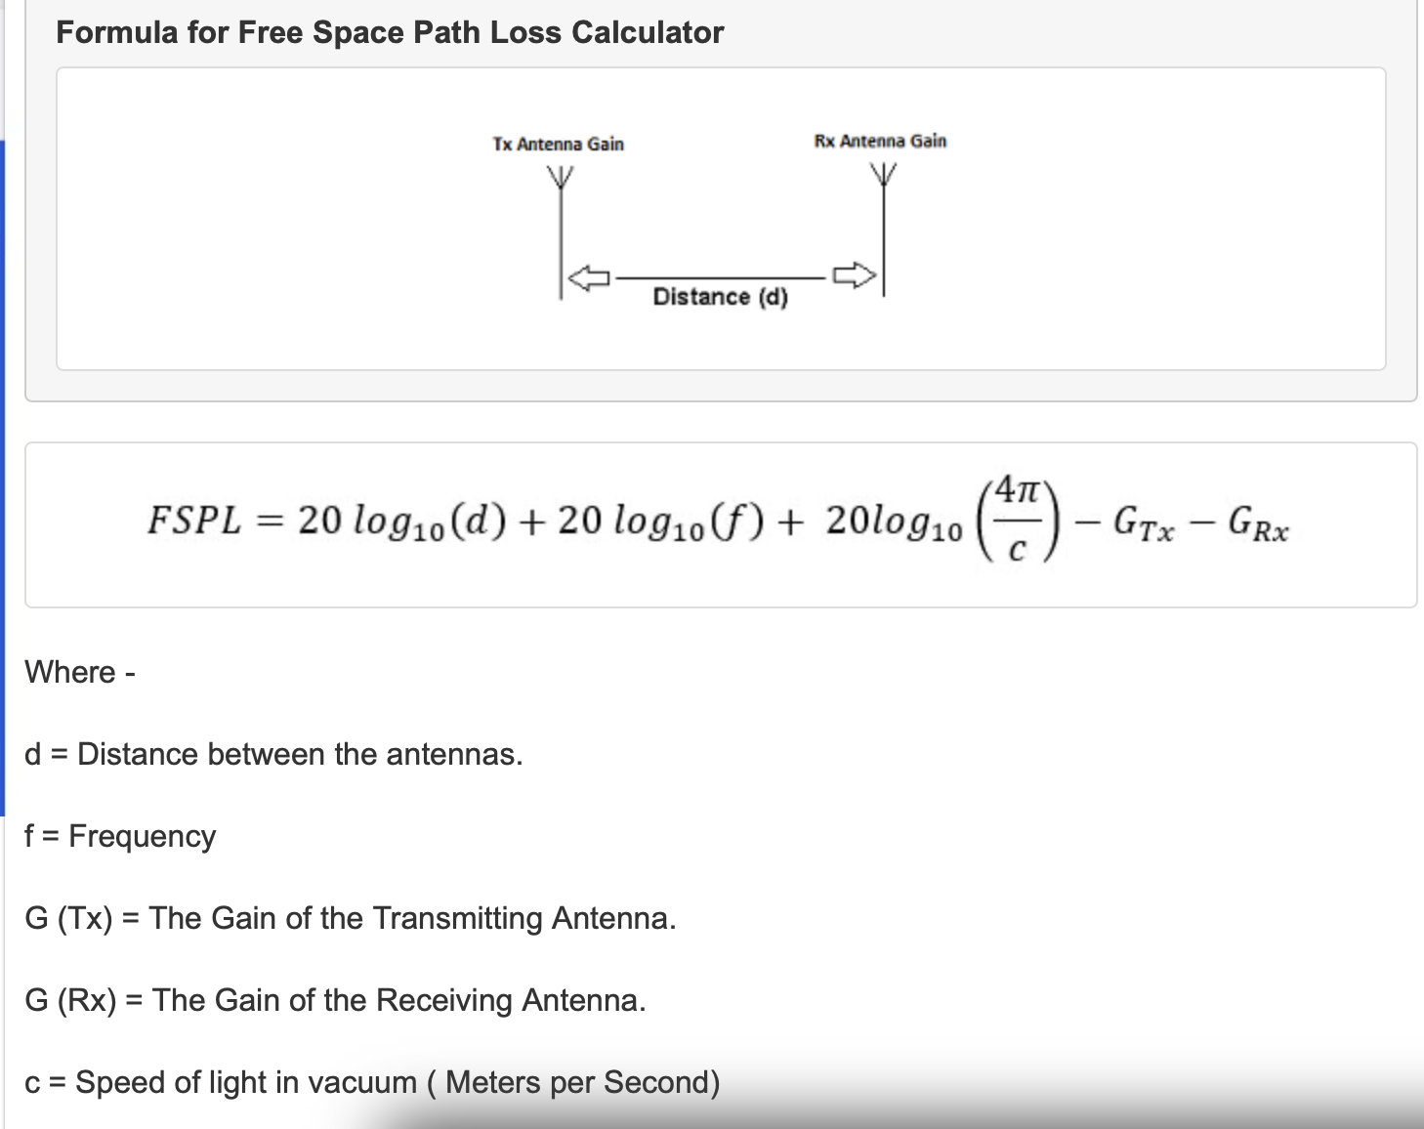
Figure 7. Formula used to calculate path loss for our setup

